**INVOICE**

Sam Bradshaw

Bell House

Silver Street

Kedington

Haverhill

CB9 7QG

Mob: 07872 597843

Date of Issue: 02/11/2018

Invoice number: 1

Client: Korg UK

Works Carried Out: Design, development and implementation of both front and back end of website [www.reonsynth.com](http://www.reonsynth.com).

**Total Cost: £1500**

Account to be credited:

Santander

Account Name: Mr S C Bradshaw

Sort Code: 09 01 29

Account Number: 02944443

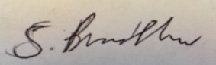

Signed: Date: 02/11/2018